LASER HAIR REDUCTION AT JUVERNE CLINIC | FREQUENTLY ASKED QUESTIONS
Why consider Laser Hair Reduction?
- The result from laser hair reduction cannot be matched by traditional methods of hair removal. Not only will you save money in the long run, but you will save yourself a lot of time that would have been spent removing the hair - and also achieve smoother skin free from ingrown hair & bumps.
- We use a USFDA approved diode laser device with powerful integrated contact cooling during the treatment which means a far more comfortable experience and a quick fix for lasting hair reduction.
How does laser remove hair?
- Laser removes the hair by a process called selective photo thermolysis, which means getting the right amount of laser energy at the right wavelength it is able to destroy the hair follicle without destroying the surrounding skin. The Light energy from the laser is transferred into thermal energy in the hair follicle. The Laser targets the Melanin, the pigmented region of the hair follicle and when the heat is absorbed by the Melanin, the follicle is destroyed.
- The Hair growth cycle has three distinct growth phases: Anagen (Active growth phase); Catagen (Regressive phase); Telogen: (Resting phase). It is ONLY during the active growth ‘Anagen’ phase that Laser can permanently disables hair growth. Hair attain anagen at different times, thus multiple treatments are needed.
What result can I expect from the treatment?
- Hair will become reduced in the treatment area and it will be much finer and less pigmented.
How many treatments will I require?
- The number of treatments are dependent on the individual. The number of treatments is also dependant on medical background & hormonal changes in the body. Some clients are happy after 6 sessions; whereas some people will desire more.
- It is important to note that maintenance sessions will be required. Usually, woman’s faces require more treatments than bodily areas. Women are predisposed to grow new hair on the face as they get older. Hormones, menopause & medication all increase growth. Areas like legs, bikini & under arms are more successful because women are predisposed to lose hair in these areas as they get older.
How often do I need to come in for treatment sessions?
- During the initial 6 treatments, we recommend treatments very 4 weeks for the face & every 6 weeks for the body areas.
- After the initial 6 treatments, the time between treatments varies from client to client.
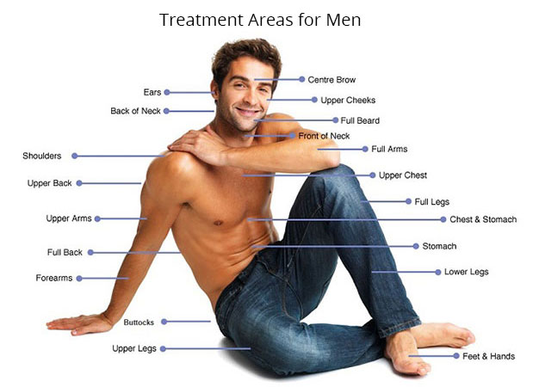Which areas can be treated with laser?
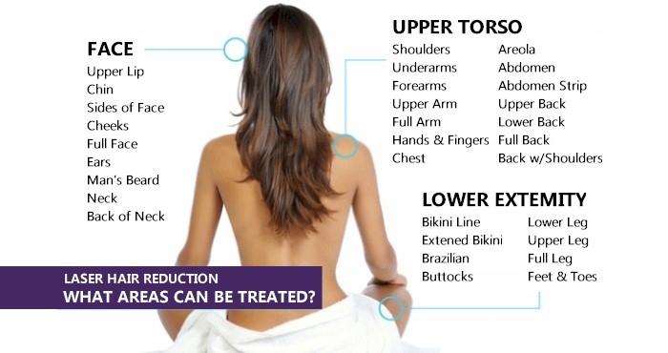

How often do I need to get laser treatments ?
- The cycle for Facial Hair renews every 4 weeks. The cycle for Body Hair renews every 6 weeks. The cycles for each hair is not synchronized and this is the reason you need that multiple treatments & at the correct gap for optimal results. ie. Every 4 weeks for Face & 6 weeks for Body treatments.
- Our laser uses different parameters to safely treat all skin and hair types - including dark skin or fine hair.
What to expect after Laser Hair Reduction?
- Convenience and hygiene - as well as treatment of bumps and ingrown hairs. Laser offers a quick and permanent solution for hair reduction.
- Laser hair reduction helps eliminate stubble and dark shadows of shaving, rashes from waxing and the pain of threading.
- Be advised to treat hair before it goes grey as the hair needs to be darker than the skin, for effective results. We cannot treat white/grey/blonde/ red hair.
- A thorough medical history and examination will be taken at the consultation in order to check that you are medically suited to having the treatment.
What happens during a laser treatment session?
- The hair should be shaved prior to the treatment. We need the hairs to be as short as possible to make the treatment more effective & as comfortable as possible. The area to be treated will be wiped & marked out in white pencil. You would be requested to check that the marked area is to your satisfaction.
- Your eyes would be covered with protective goggles and the area will be treated with a laser applicator, with a built in cooling device to ease pain & reduce sensitivity. At the end of your session cooling and moisturizer, post treatment medication and sunscreen (if necessary) will be applied
Is Laser Hair Removal permanent?
- At Juverne we make it very clear that there is no such thing as permanent hair removal, it is called Permanent Hair Reduction.
- The goal of the treatment is to significantly reduce the amount of hair growth, and for the hair to grow back lighter and softer, giving you a long hair free period. You may need maintenance treatments after many years - or may need additional sessions if you experience hormonal changes such as those arising from a disease, PCOD or other imbalance, side effects of certain medication or the normal changes in hormones seen during pregnancy.
- Laser treatments will get rid of coarse dark hair & leave you with much smoother skin.
Is the treatment painful?
- Treatments with our laser device are five times faster and significantly more comfortable - actually painless - than other laser hair reduction methods. We use a patented scanning technology that allows rapid treatment and strong inbuilt cooling even over large areas to ensure that you are done in minutes.
Do I have to grow my hair?
- You should have short visible hair when you come for a consultation so we can better advise you on you hair type & suggest the most appropriate treatments. There is no need to grow your hair out for regular treatments; you may shave as many times as you wish, this will not affect the results.
- The following methods are suitable for removing hair: Shaving – removing the hair by using a blade. Trimming – removing the hair by the use of a machine to cut the hairs; Hair Removing Creams – removing the hair by applying a non invasive cream that removes hair without affecting the follicle.
- The following methods should not be used to remove hair: Bleaching – Lightening the hair using harsh chemicals; Epilating – removing the hair, including the follicle, by a pulling motion. Included in this are Waxing, Epilating Machines, Plucking, Threading, Tweezing and more.
What about a patch test?
- A patch test is done on a small section on each different body areas you want treated. The Patch Test provides us the optimal temperature for your skin and checks the sensitivity leave if your skin. The purpose of the patch test is to highlight any adverse reactions you may have to the treatment.
- We offer a complimentary Patch Test with a consultation with our doctors. Treatments or patch tests are not done without consulting the doctor first.
How long will it take?
- With our revolutionary laser you can expect significantly shorter treatment times. We can treat a full male back in 15 minutes. Treatment on a full face can take as little as 5 minutes or the underarms in 1 minute, whereas full legs will take up to 45 minutes, depending on the surface area and skin condition.
Are there any Possible side effects?
- After the treatment you can get temporary erythema (redness) or temporary per-follicular oedema (swelling/lumps)
- In some rare cases, people have suffered from temporary blistering and scabbing.
- Any initial reactions should settle down within a 48 hours period.
- Bland moisturizer or aloe vera gel and cold running water or cool compresses (not ice) should be used to reduce irritation.
- There is also a very slight risk of hyper- and hypo- pigmentation. This is the darkening and lightening of the skin, which is why it is important to protect the skin from the sun using medical grade sunblock of SPF 30 or above.
- If you have a history of herpes/cold sores, you may get a relapse after any treatment. The doctor can prescribe medication to prevent this, in advance.

INSTRUCTIONS FOR TREATMENT
BEFORE YOUR SESSION:
- Moisturize skin well twice a day for a week before the treatment.
- Shave the areas to be treated carefully the night before treatment.
- Mention all that apply: a tendency to scar / recent tan / keloid / cold sores
- Inform us if you have a history of Cold Sores / Herpes to receive advice on prophylactic antiviral medication.
- Skin can be more sensitive just before / during periods. You may wish to take a painkiller or delay treatment.
- 3 DAYS BEFORE treatment: Avoid topical products such as Tretinoin (Retin-A), Retinols, Retinoids, Glycolic Acid, Alpha Hydroxy Acid, or any “anti-aging” products. Also avoid waxing, bleaching, tweezing, or the use of hair removal cream on the area to be treated. Avoid green tea/coffee and black tea/coffee, add milk instead.
- Do not undergo laser hair reduction if you are pregnant or breastfeeding, are allergic to light, or suffer from any ongoing skin infections. Please inform your provider if you have any questions about this prior to the treatment & share allergies and history of medication & treatment even unrelated to skin/hair.
- Bring information of skin care & medication taken, esp. Isotretinoin & Birth Control
AFTER YOUR SESSION:
- Protect your skin by using sunscreen and moisturizer, as well as prescribed post treatment creams.
- Use a broad-spectrum, SPF 30+, and water-resistant sunscreen everyday on all exposed areas.
- In case of any itching, burning or other reactions, rinse with cold water. Do not apply ice.
- Contact the clinic in case of severe discomfort and ask to speak with the doctor urgently.
- Do not tan (outdoors and indoors). Also, do not use sunless tanners.
- Avoid swimming, heavy sweating, synthetic clothing, scrubs and skin care products/treatments on the treated area for 1 week.
- Within a few days to weeks of your successful laser treatment, you may notice hair growing back. This is expected and normal - and may occur more in some persons than others. This is not a sign of a poor laser treatment and you should not do any sessions befor 4-6 weeks from the previous one. The hair thus seen may be shedding growth (from follicles which were in anagen and did get targeted) that easily falls off on tugging; or it may be new growth (from follicles which were not in anagen and thus could not have been targeted by your laser treatment) which will get covered in the next session. This is why the laser treatment needs multiple sessions - you may shave or use depilatory creams as often as desired, between sessions. You may choose to do nothing at all, which is fine too. Waxing, threading, sugaring or plucking, epilation and any method that removes hair from the root should not be used between sessions of Laser.
ON THE DAY OF TREATMENT
- Please come to the office with a “clean face” – i.e. washed and having applied moisturizer only. Please do not wear makeup. You may wish to bring your own sunscreen and makeup to apply immediately after your treatment.
- To maximize your comfort during some not all procedures, a topical anaesthetic may be applied after a brief patch test. In some cases, a local numbing medication will be injected into or around the area(s) to be treated.
- You may experience a mild amount of discomfort or pain during laser. To ensure a smooth and even correction, your provider may massage the area(s) treated, which may cause a temporary, minimal amount of redness to your skin.
IN CASE OF FURTHER QUESTIONS: Please contact our team at 09910912141. You may call Dr Sonam Yadav on her mobile phone in case of serious urgent concerns.

